4. Django Project MVT Structure

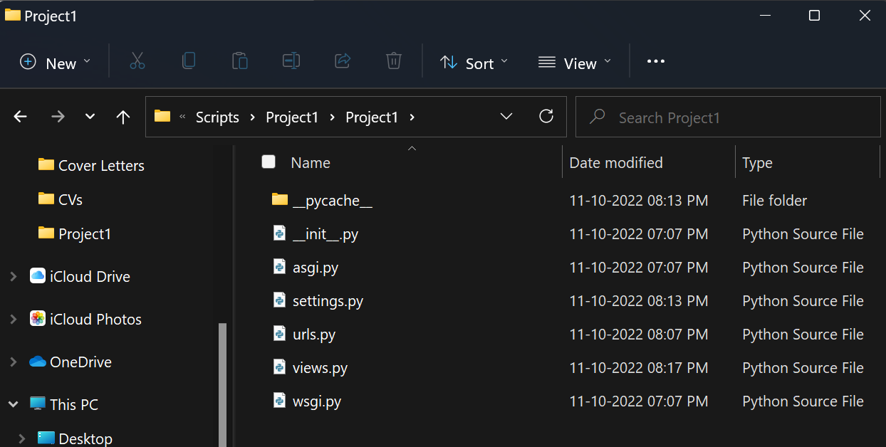

5. Create a Basic Project using MVT in Django

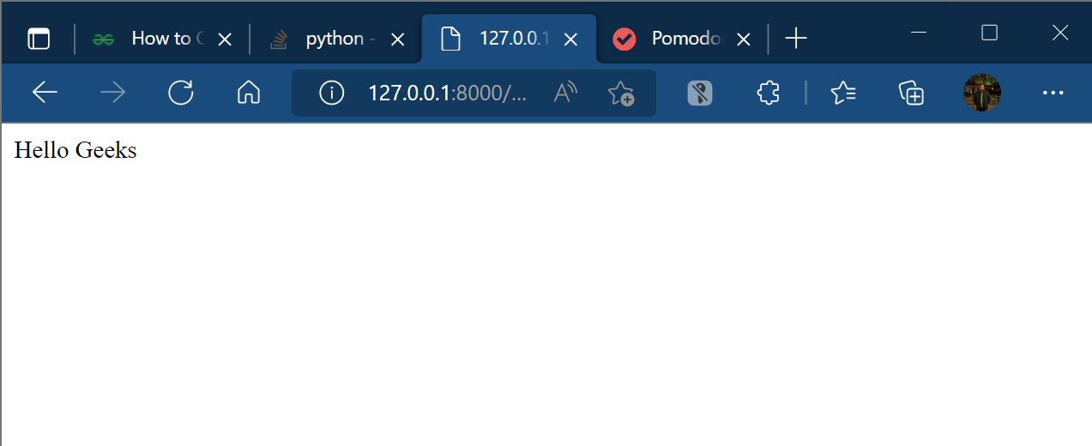

6. Create an App in Django

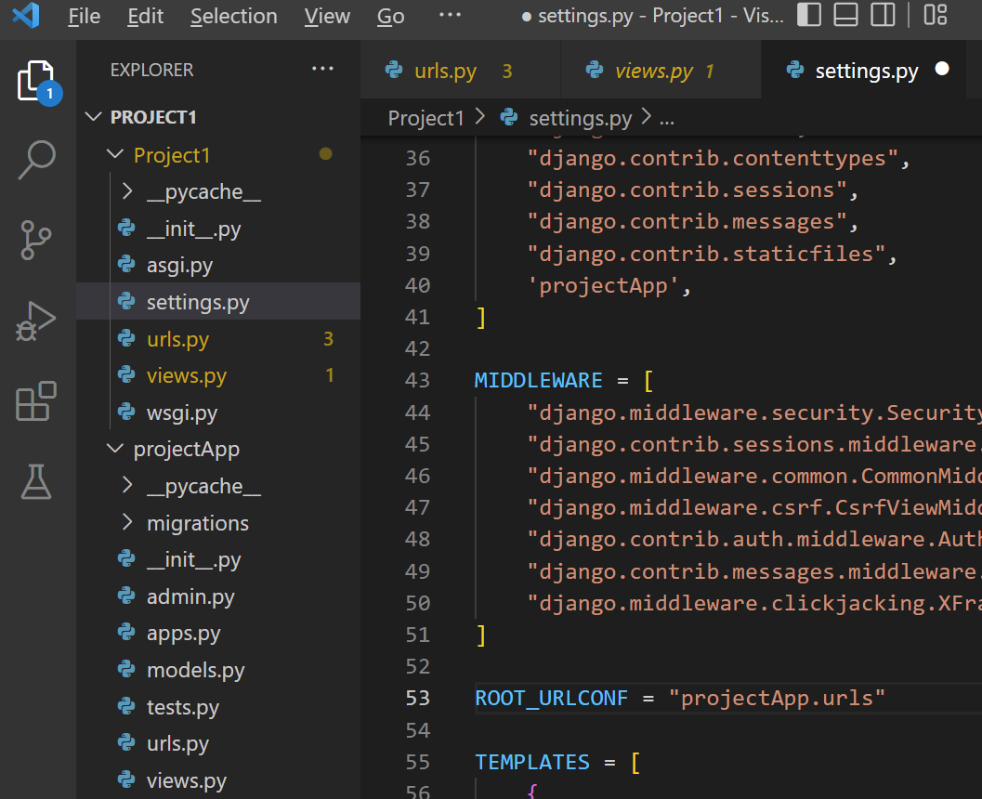

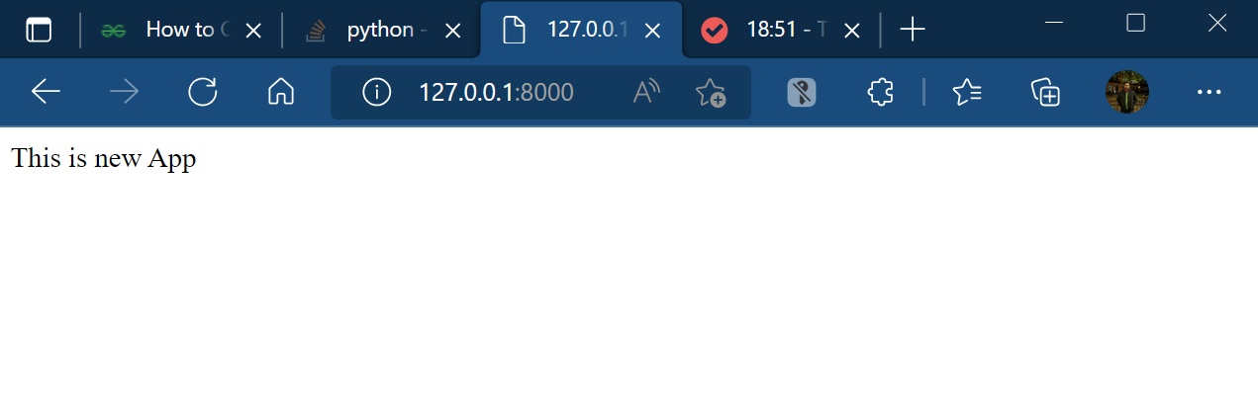

7. Django Forms

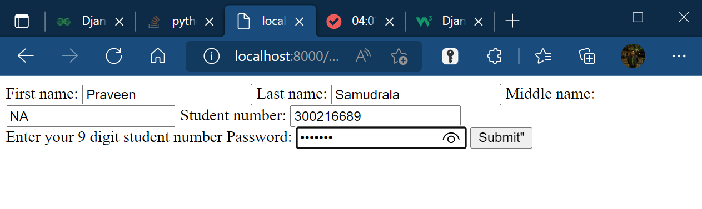

8. Render HTML Forms (GET & POST) in Django

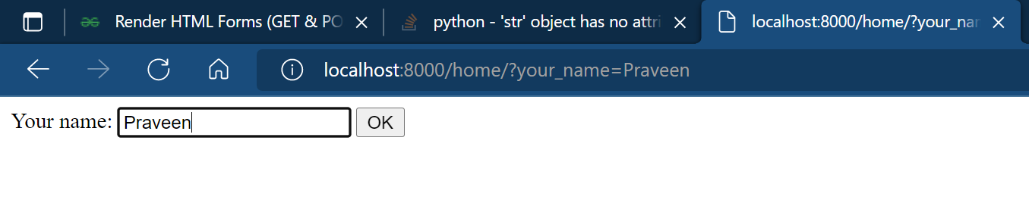

Get request



POST request



9. Django form field custom widgets

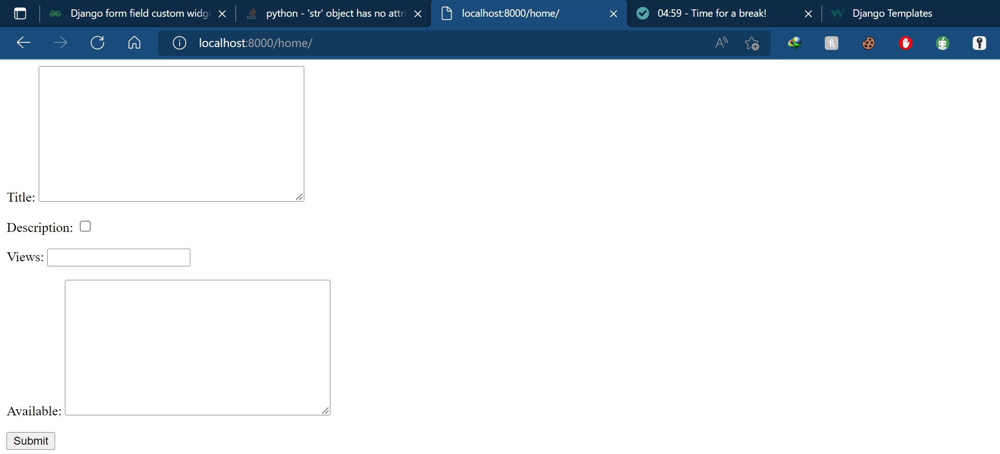

10. Django ModelForm – Create form from Models

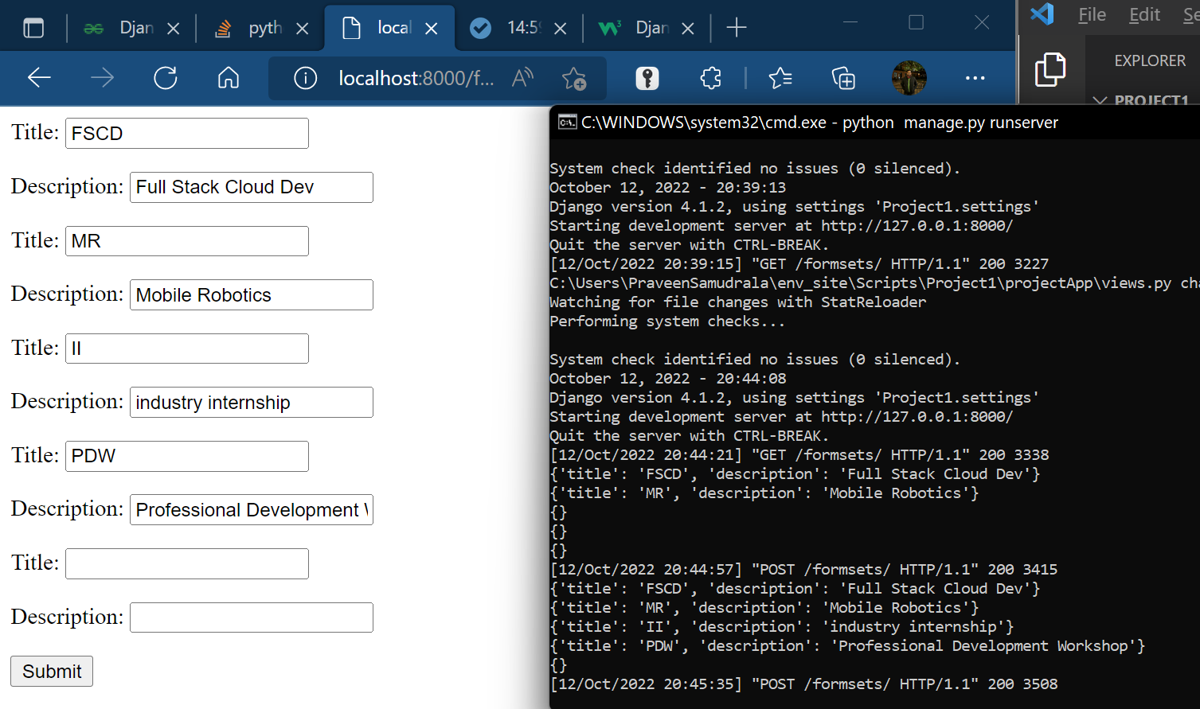

11. Model formsets

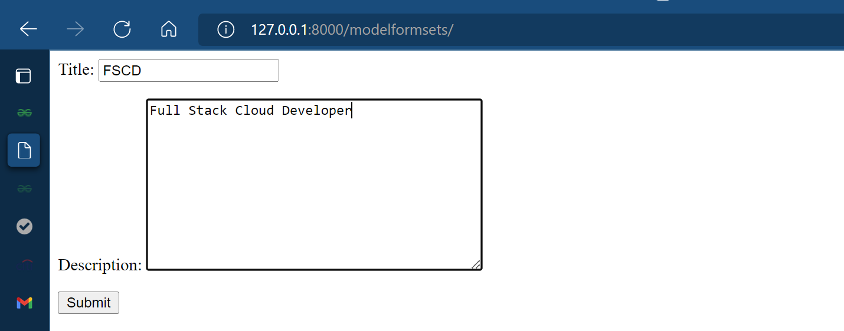

Multiple Model formsets

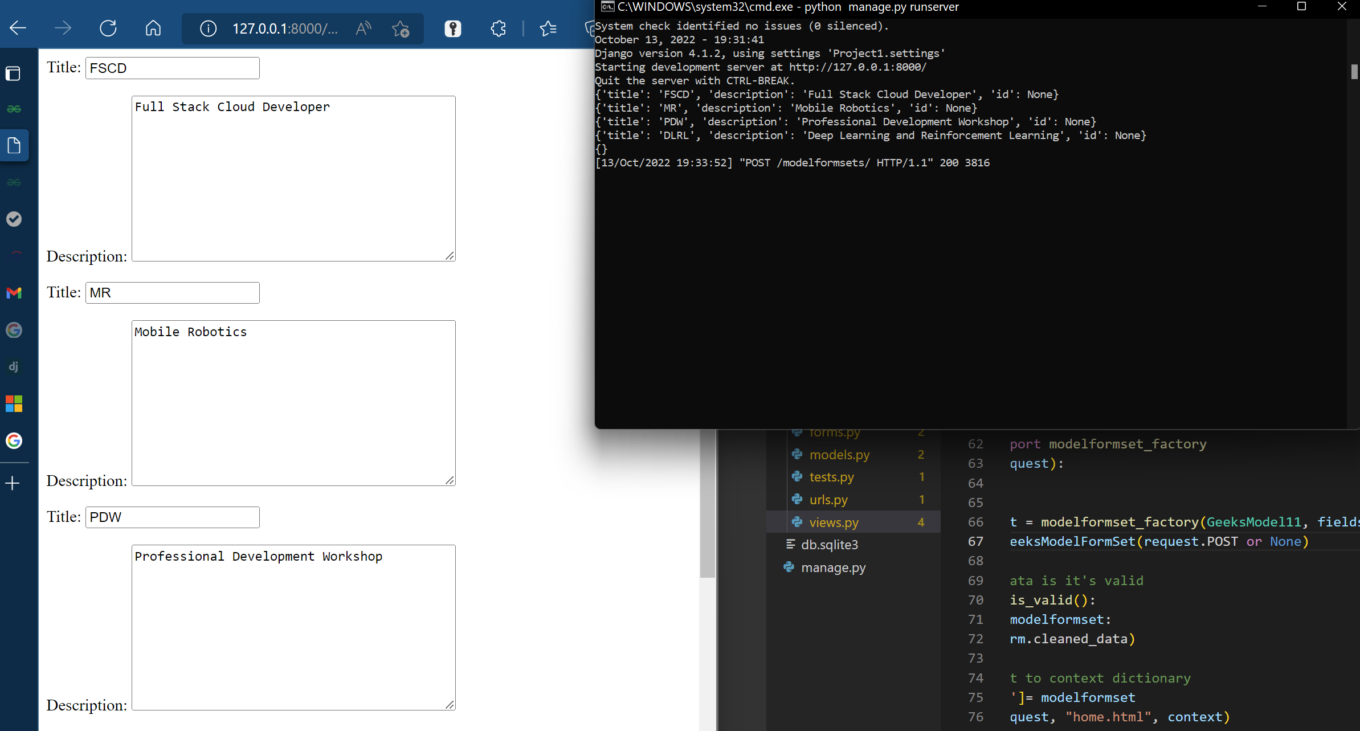

12. Templates

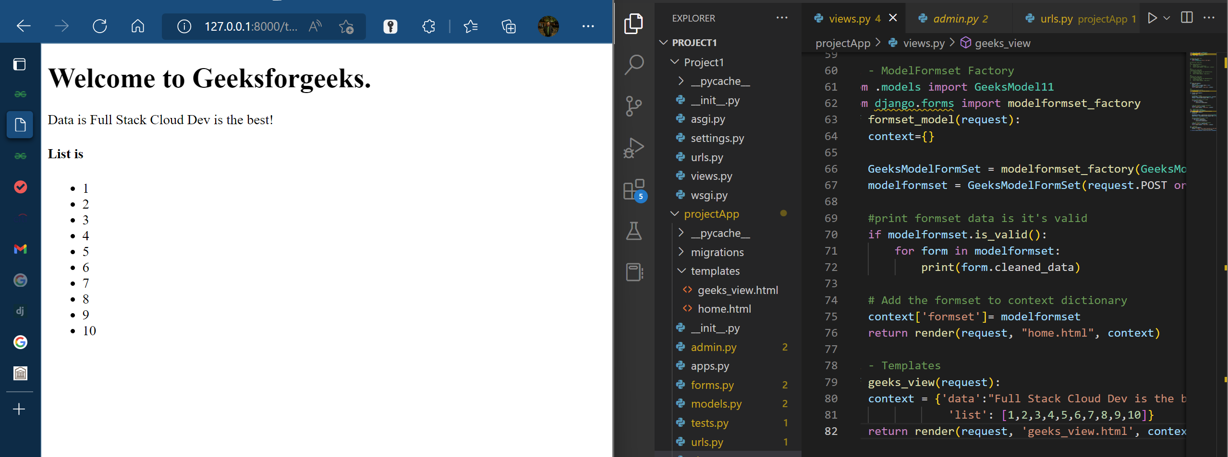

13. Views In Django | Python

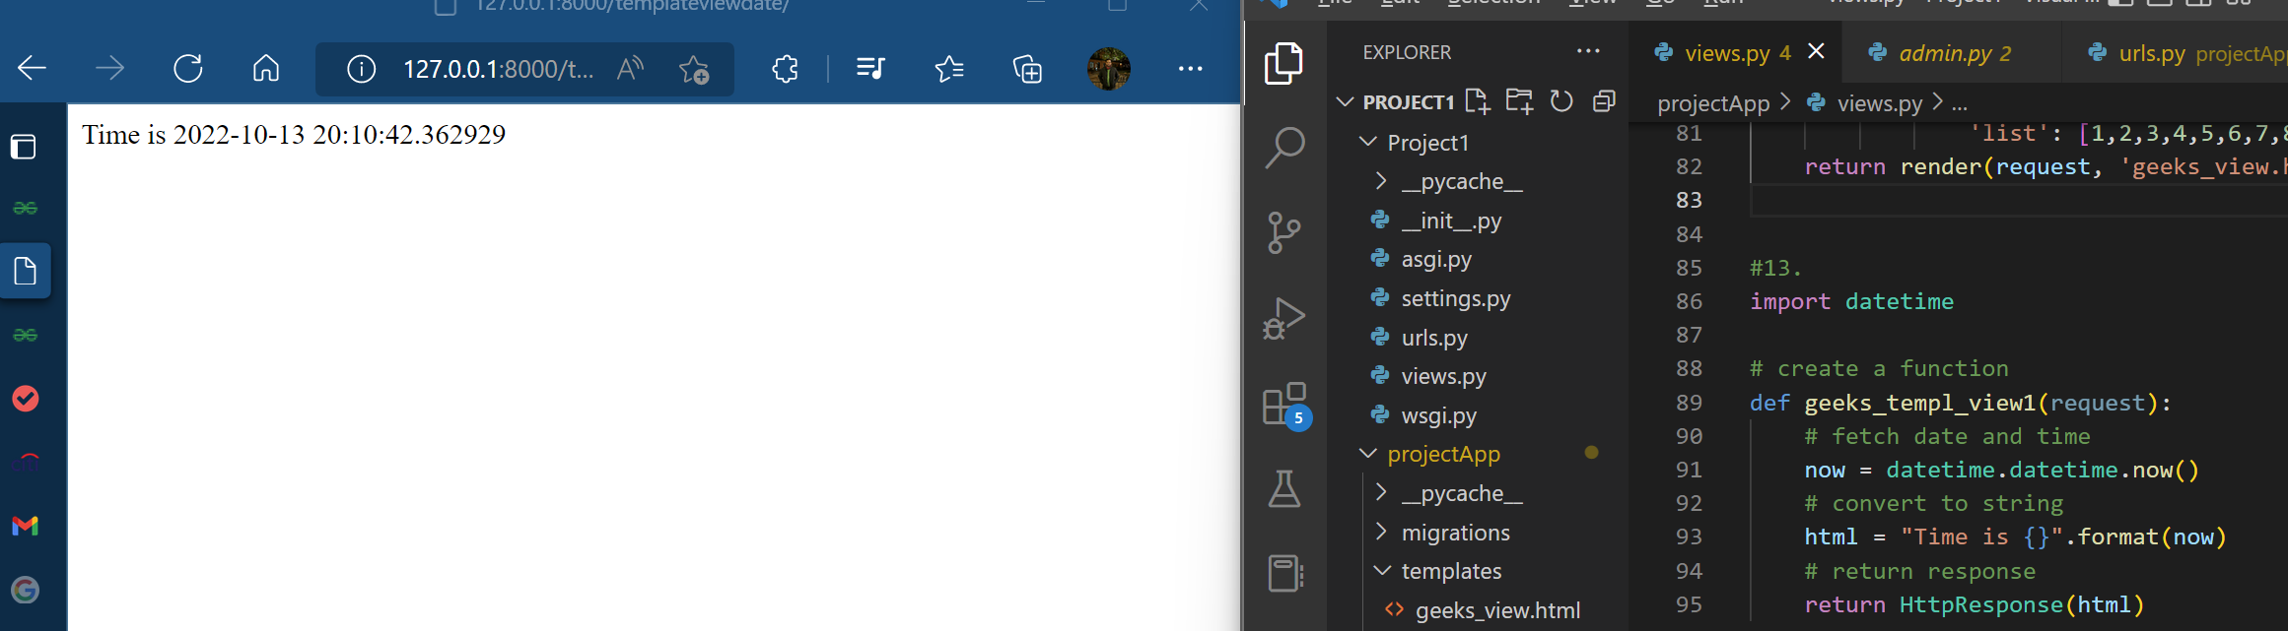

Function based views of database objects

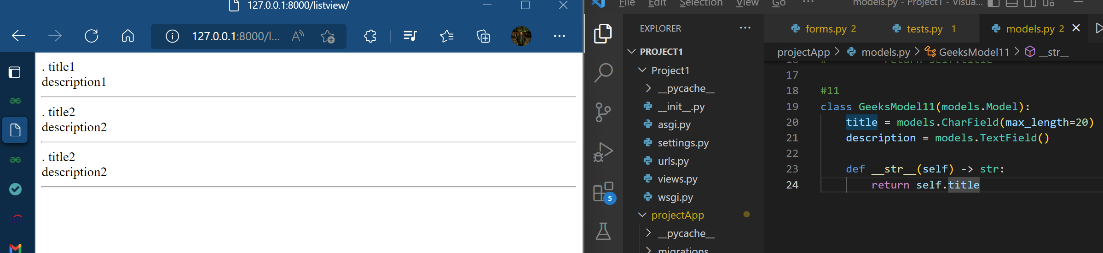

14 - Django CRUD (Create, Retrieve, Update, Delete) Function Based Views

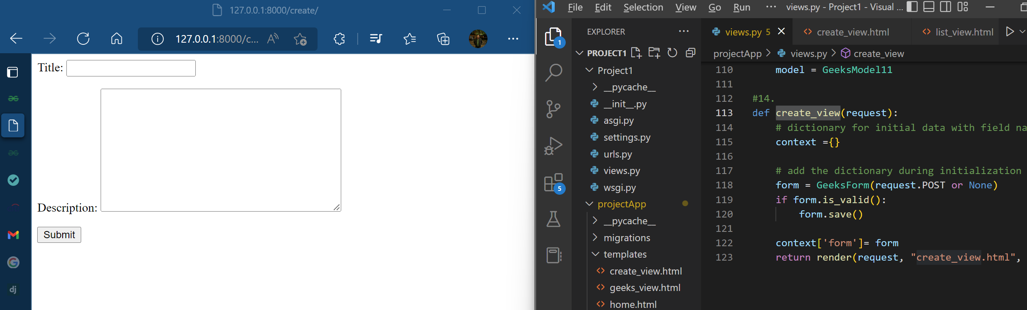



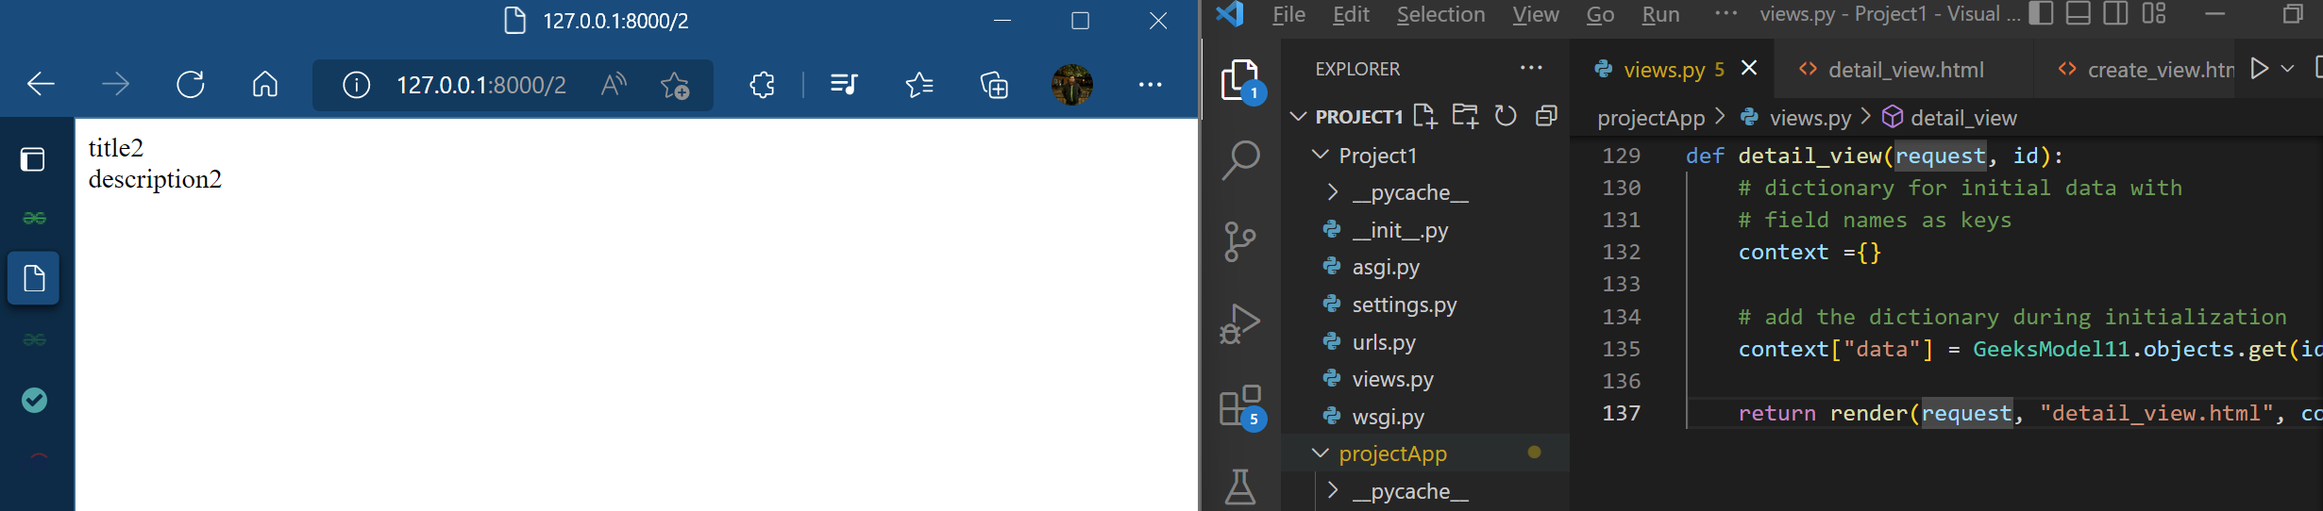

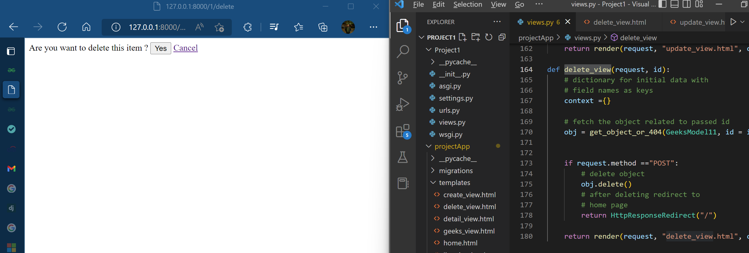

Models CRUD

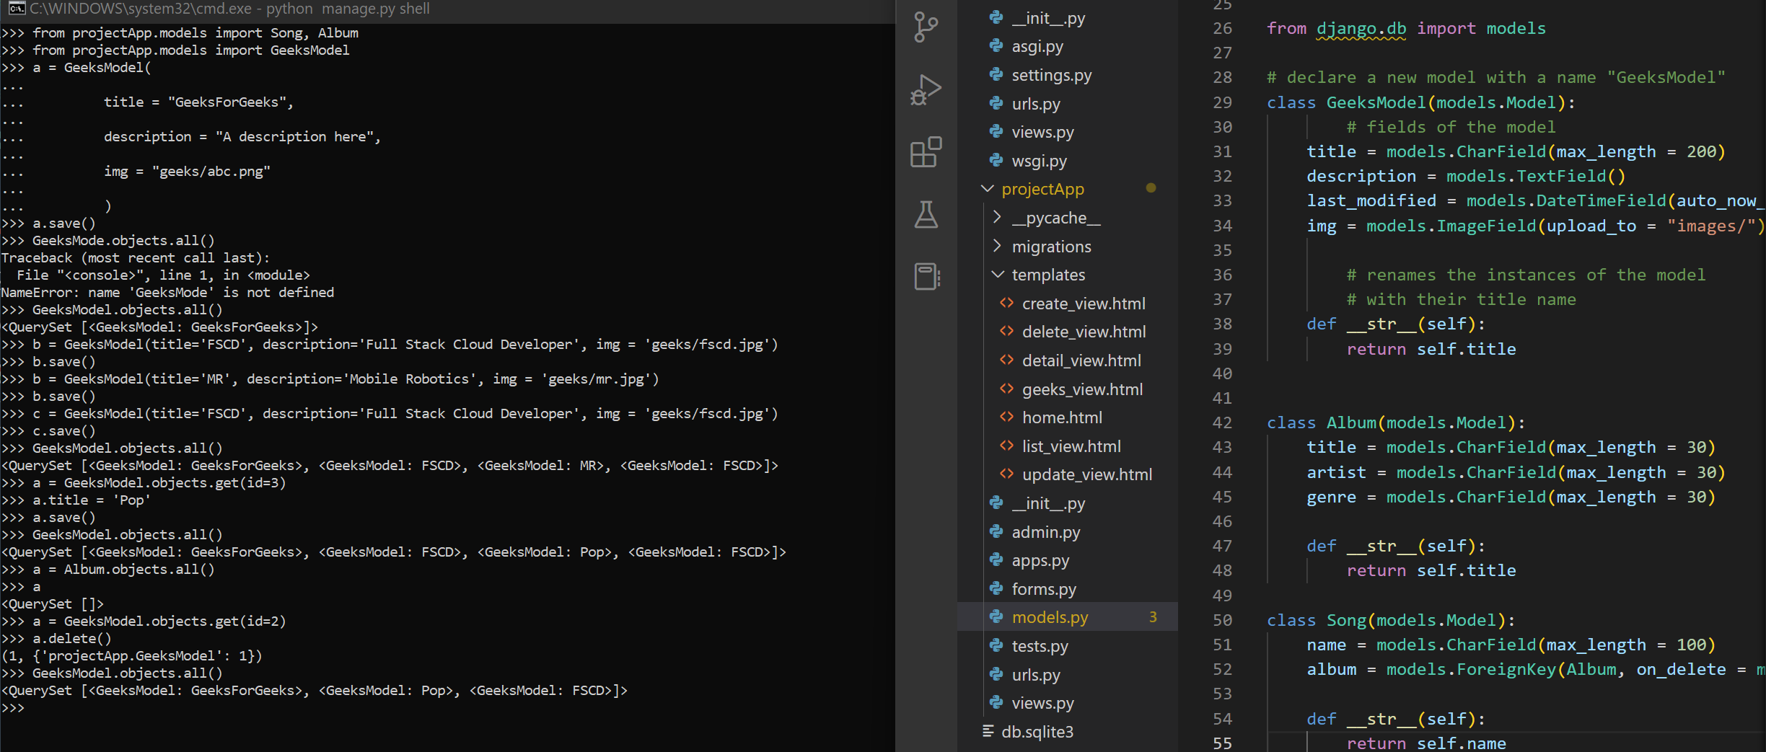

Models migrate

